HandsOn Assignment:
Q.1)
ANS) SELECT ENAME, SAL, COMM FROM EMP WHERE COMM IS NOT NULL ORDER BY 2 DESC, 3 DESC;
Q.2)
ANS) SELECT DISTINCT job_code FROM EMP;
Q.3)
ANS) SELECT emp_id AS "Emp #", emp_name AS "Employee", job_code AS "Job", hire_date AS "Hire Date" FROM EMP;
Q.4)
ANS) SELECT last_name || ', ' || job_id AS "Employee and Title" FROM employees;
Q.5)
ANS) SELECT ENAME || ',' || JOB || ',' || HIREDATE || ',' || MGR AS THE_OUTPUT FROM EMP;
Q.6)
ANS) SELECT ename, job, hiredate FROM EMP WHERE ename = 'SCOTT' OR ename = 'TURNER'
ORDER BY hiredate ASC;
Q.7)
ANS) SELECT ename, deptno FROM EMP WHERE deptno = 20 OR deptno = 30
ORDER BY ename ASC;
Q.8)
ANS) SELECT ename AS "Employee", sal AS "Monthly Salary" FROM EMP WHERE sal BETWEEN 2000 AND 3000 AND deptno IN (20, 30);
Q.9)
ANS) SELECT ename, hiredate FROM EMP WHERE hiredate LIKE '%81';
Q.10)
ANS) SELECT Ename, SaL FROM EMP WHERE Sal > &user_specified_amount;
Q.11)
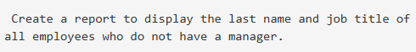
ANS) SELECT ename, job FROM EMP WHERE mgr IS NULL;
Q.12)
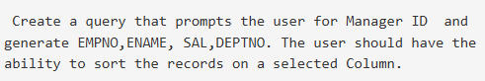
ANS) SELECT empno, ename, sal, deptno FROM EMP WHERE mgr = &enter_manager_id
ORDER BY &select_sort_column;
Q.13)
ANS) SELECT empno, ename, sal, deptno FROM EMP WHERE mgr = &enter_manager_id
ORDER BY &select_sort_column;
Q.14)
ANS) SELECT ename FROM EMP WHERE ename LIKE '__A%';
Q.15)
ANS) SELECT ename FROM EMP WHERE ename LIKE '%A%' AND ename LIKE '%S%';
Q.16)
ANS) SELECT Ename, Job, Sal FROM EMP WHERE Job = 'CLERK' AND Sal IN (800, 950, 1300);

